total 60

Answer the following questions

Question 1 10 marks – 1 mark each

1. Write a shell command to list all files and directories in the "/usr/bin" directory.

2. Write a shell command to move all files with the ".txt" extension from the current directory to the "/home/user/docs" directory.

3. Write a shell command to compile a C program called "myprog" that uses the math library and source code files located in the "/home/user/proj" directory.

4. Write a shell command to commit changes to a Git repository with the message "Updated README file".

5. Write a shell command to search for all occurrences of the string "error" in a log file called "server.log".

6. Write a shell command to count the number of lines in a file called "data.txt" that contain the string "hello".

7. Write a shell command to find all files in the "/home/user" directory modified within the last 24 hours.

8. Write a shell command to remove all files with the ".bak" extension in the current directory.

9. Write a shell command to rename a file called "oldname.txt" to "newname.txt" in the "/home/user/docs" directory.

10. Write a shell command to create a new directory called "mydir" in the parent directory of the current directory.

QUESTION 2 (6 marks - 1 mark each)

Write C declarations that declare variable “my_ptr” to be a:

(a) pointer to an array of 5 integers.

(b) pointer to a function that takes an integer argument and returns void.

© pointer to a structure with two integer members “x” and “y”.

(d) pointer to a char string.

(e) double pointer to an integer value.

(f) void pointer.

QUESTION 3 (4 marks - 1 mark for each address)

A machine uses 16KiB pages. Suppose a process on this machine has the following page table. All numbers are in base 10.

|  |  |
| --- | --- |
| Page Number | Frame number |
| 0 | - |
| 1 | 41 |
| 2 | 42 |
| 3 | - |
| 4 | 144 |
| 5 | 43 |
| … |  |
| 50 | 541 |
| 51 | 376 |
| 52 | 564 |
| 53 | 191 |
| … |  |
| 8191 | 1023 |
| 8192 | 971 |

For each of the following virtual addresses, what is the corresponding physical address?Write your answer in base 10. If accessing the virtual address would result in a segmentation fault, then write "SEGFAULT". If there is insufficient information in the page table (i.e. the page number is not listed) then write "UNKNOWN"

|  |  |
| --- | --- |
| Virtual Address | Physical Address |
| 7456 |  |
| 23300 |  |
| 833000 |  |
| 811600 |  |

QUESTION 4

(5 marks - 1 mark each)

Suppose a system supports process memory spaces up to 64 TiB.(1TiB = 1024 GiB.)Suppose also that it supports 40-bit physical addresses and uses a three-level page table.Pages are 16KiB in size. Page table entries are 8 bytes each.A process uses the following virtual address range (all numbers are in base 10):96 GiB starting at address 0

(a) What is the number of bits in virtual addresses on this system?

(b) How much memory (in KiB) would be needed to store the page table for this process?

(c) If the process memory usage expanded to 256GiB (all starting at address 0), how much memory (in KiB) would now be needed to store the page table?

(d) If a process used all of its virtual address space, how much memory (in GiB, to the nearest GiB) would be needed to store the page table?

(e) If the original process (using 96GiB at address 0) also used 1GiB at the highest virtual addresses, then how much memory (in KiB) would be needed to store the page table?

(b)What is the maximum number of processes that could be running or runnable at any point?

(c)What is the minimum number of lines of text that this program will output when run?

(d)What is the maximum number of lines of text that this program will output when run?

(a)6

|  |  |  |  |
| --- | --- | --- | --- |
|  | Netmask | Broadcast Address | CIDR |
| A |  |  |  |
| B |  |  |  |
| C |  |  |  |
| D |  |  |  |

2

a e f





Q8 6





q9

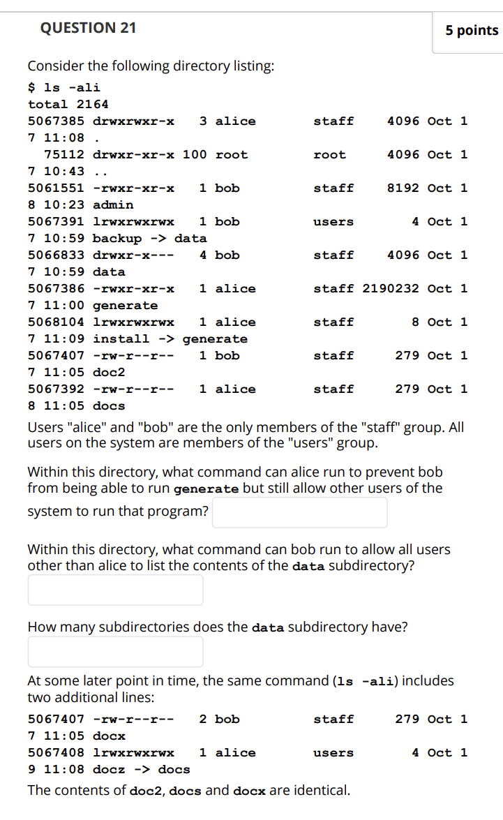

Question 10 (4 marks)

The code below tries to find the maximum number of an array, and its index.

There are four mistakes.

